Epigenetic Link to Cell Cycle Regulation in human ESCs
Recent studies have begun to uncover the link between the cell cycle and the maintenance of pluripotency in embryonic stem cells (ESCs) and induced pluripotent stem cells (iPSCs). Pluripotent cells present with a smaller percentage of cells in G1 phase, which in itself is shorter in pluripotent cells than most other cell types, but acquire a lengthened G1 phase upon differentiation. Mounting evidence suggests that this may be controlled by CDK2 and low levels of two cyclin‐CDK2 inhibitors CDKN1A (p21) and CDKN1B (p27), and the regulation of these genes expression has come under scrutiny. In a recent study in Stem Cells, the group of Julie Baker report on their studies into JMJD5, a JmjC (Jumonji C) domain containing protein family which can control gene transcription by catalysing histone demethylation, finding that JMJD5 is necessary for regulation of the G1 phase as well as for the maintenance of pluripotency in ESCs [1].
Initial comparisons of G1/S transcripts specific for hESCs identified 51 genes that remain constant in hESCs but fluctuate in differentiated cells between G1 and G1/S phase. Of these, JMJD5, understood to function as a cell cycle and cell proliferation regulator [2], was highly expressed in both hESC G1 and G1/S phases and at a low level in G1 in differentiating cells. JMJD5 expression also increased dramatically at G1/S phase whilst both transcripts and proteins were consistently high from G1 to S phase in hESCs and much lower in differentiated cells. This all suggests that JMJD5 has a distinct role in a rapid G1 phase of the cell cycle in hESCs. Indeed, short hairpin RNA mediated downregulation of JMJD5 in hESCs led to the growth of enlarged and flattened hESC colonies, decreased expression of OCT4, NANOG and SOX2 mRNA, SSEA3 and SSEA4, increased expression of differentiation-associated marker expression, and inhibition of proliferation.Turning to the cell cycle, depletion of JMJD5 led to an increase in the fraction of cells in G1 phase, while synchronization studies found a significant retention in G1 phase in JMJD5-depleted cells, altogether indicating that JMJD5 plays a role in the timing of the G1 phase in hESCs.
Focusing on the transcriptional role of JMJD5, the authors found that of known G1‐S transition components, CDKN1A mRNA and protein was significantly upregulated in response to JMJD5 loss, while overexpression of JMJD5 led to a significantly reduced CDKN1A mRNA expression, suggesting a normally repressive transcriptional role. Furthermore, the microRNA family miR‐302, known to post transcriptionally inhibit CDKN1A [3], was downregulated in response to JMJD5 loss, while both luciferase and chromatin immunoprecipitation‐qPCR assays both suggested that JMJD5 targets the miR-302 promoter directly (See figure). hESCs modified to lack CDKN1A or CDKN1A and JMJD5 formed hESC-like colonies, suggesting that while CDKN1A loss had little effect on pluripotency, it was able to reverse the loss of pluripotency observed in the JMJD5-negtive hESCs and to partially rescue all cell cycle phenotypes seen under JMJD5 loss. Interestingly, detailed experiments found that the changes in the cell cycle observed with loss of JMJD5 came before the loss of the pluripotent phenotype; by day three of JMJD5 inhibition, cells began to accumulate in G1 phase and CDKN1A expression was induced, while pluripotency marker gene expression levels remained unaltered, suggesting that the JMJD5/CDKN1A (p21) interaction is specific to the cell cycle and not a result of the loss of pluripotency and differentiation into a distinct cell type.
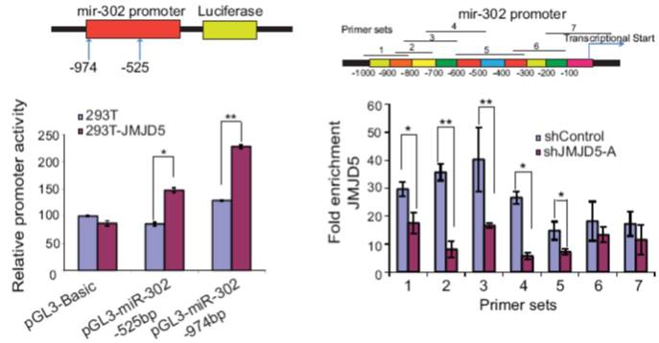
Overall, the authors’ detailed analyses propose that JMJD5 mediates the quickened G1 phase in hESCs by activating CDKN1A which precedes the loss of pluripotency. Specifically, JMJD5 regulates the expression of miRNAs from the miR-302 cluster which regulate the expression of CDKN1A. The authors point to the extensive data sets collected within this study, and from other similar studies [4], as a valuable resource for future studies, which will hopefully extend out the network of genes which regulate pluripotency and the cell cycle giving valuable insights to areas such as induced reprogramming.
References
- Zhu H, Hu S, and Baker J JMJD5 regulates cell cycle and pluripotency in human embryonic stem cells. Stem Cells 2014;
- Hsia DA, Tepper CG, Pochampalli MR, et al. KDM8, a H3K36me2 histone demethylase that acts in the cyclin A1 coding region to regulate cancer cell proliferation. Proc Natl Acad Sci U S A 2010;107:9671-9676.
- Dolezalova D, Mraz M, Barta T, et al. MicroRNAs regulate p21(Waf1/Cip1) protein expression and the DNA damage response in human embryonic stem cells. Stem Cells 2012;30:1362-1372.
- Medina R, Ghule PN, Cruzat F, et al. Epigenetic control of cell cycle-dependent histone gene expression is a principal component of the abbreviated pluripotent cell cycle. Mol Cell Biol 2012;32:3860-3871.

